Smoking prevalence in young adults aged 18 to 34 years in Yorkshire and the Humber

Smoking prevalence in all adults (18+) in Yorkshire and the Humber was 15.7% in 2019 which was significantly higher than the England average of 13.9% and represents around 677,000 smokers.
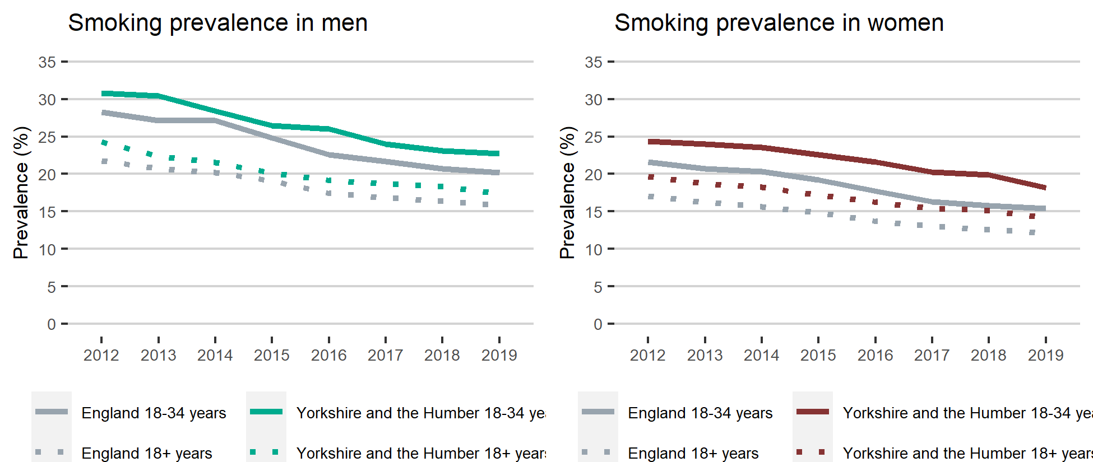

Smoking prevalence in young white men and women
In Yorkshire and the Humber smoking prevalence in young white men aged 18 to 34 years was significantly higher than all white men aged 18+. Similarly for white women aged 18 to 34, smoking prevalence was significantly higher than all white women aged 18+. Looking at smoking prevalence by socio-economic group in Yorkshire and the Humber for both white men and women the smoking prevalence within routine and manual workers was significantly higher than managerial and professional workers.

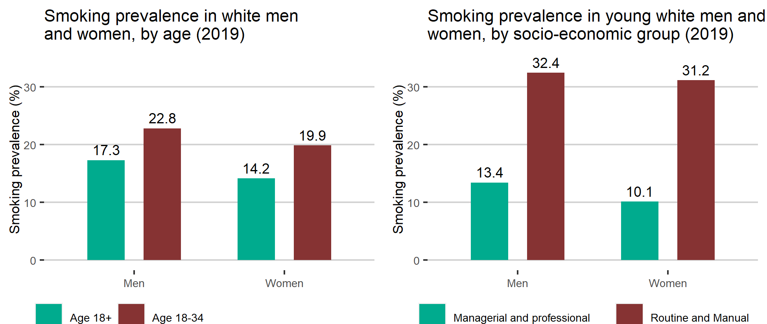
Data is available here

