Smoking prevalence in young adults aged 18 to 34 years in the West Midlands

Smoking prevalence in all adults (18+) in the West Midlands was 14.1% in 2019 which was similar to the England average of 13.9% and represents around 648,000 smokers.
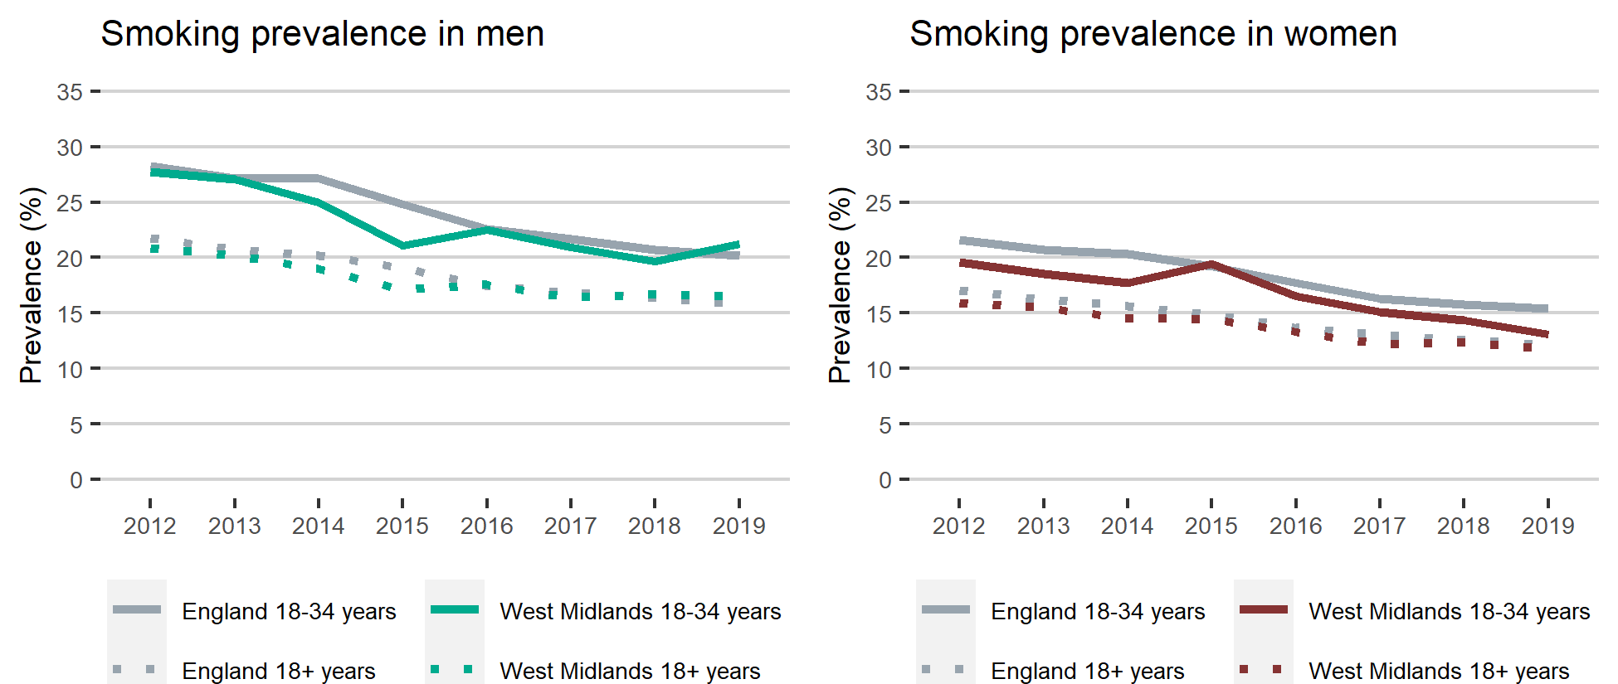

Smoking prevalence in young white men and women
In the West Midlands smoking prevalence in young white men aged 18 to 34 years was significantly higher than all white men aged 18+. Whereas for white women aged 18 to 34, smoking prevalence was similar to all white women aged 18+. Looking at smoking prevalence by socio-economic group in the West Midlands for both white men and women the smoking prevalence within routine and manual workers was significantly higher than managerial and professional workers.

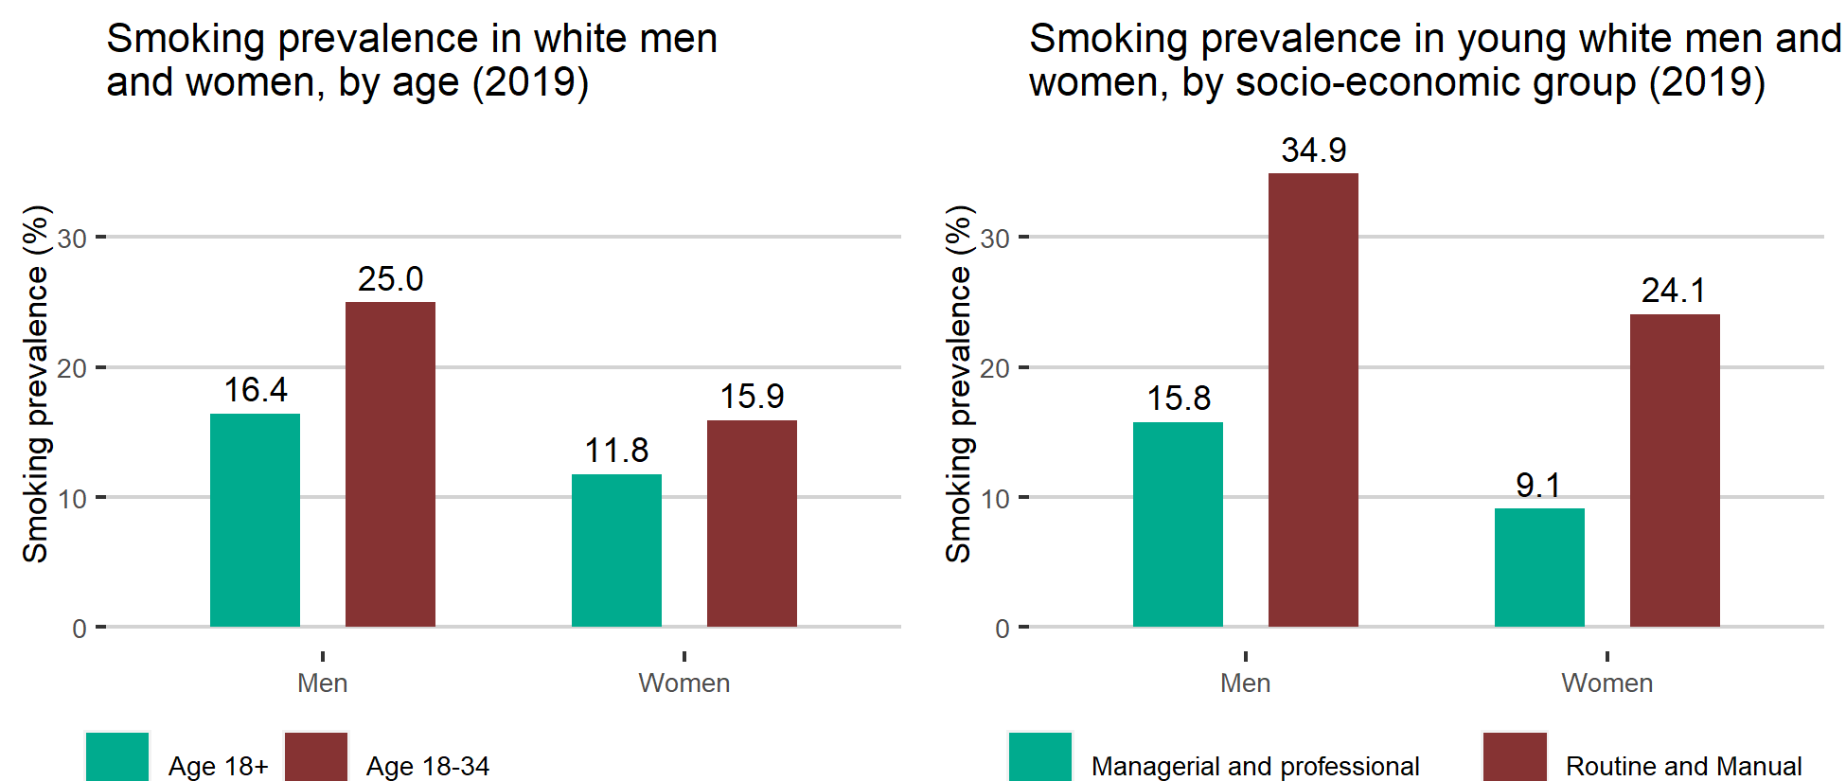
Data is available here

