National GP Profiles
User Guide v 3.0

About Public Health England
Public Health England exists to protect and improve the nation's health and wellbeing, and reduce health inequalities. It does this through world-class science, knowledge and intelligence, advocacy, partnerships and the delivery of specialist public health services. PHE is an operationally autonomous executive agency of the Department of Health.

Public Health England
Wellington House 133-155
Waterloo Road London
SE1 8UG Tel: 020 7654 8000
www.gov.uk/phe
Twitter: @PHE_uk
Facebook: www.facebook.com/PublicHealthEngland

Prepared by: John Battersby and Doris Hain
For queries relating to this document, please contact: ProfileFeedback@phe.gov.uk

© Crown copyright 2016
This publication is licensed under the terms of the Open Government Licence v3.0 except where otherwise stated. To view this licence, visit: nationalarchives.gov.uk/doc/open- government-licence/version/3 or write to the Information Policy Team, The National Archives, Kew, London TW9 4DU, or email: psi@nationalarchives.gsi.gov.uk.
Where we have identified any third party copyright information you will need to obtain permission from the copyright holders concerned.
Any enquiries regarding this publication should be sent to us at publications@phe.gov.uk
First Published December 2014 PHE publications gateway number: 2014-626

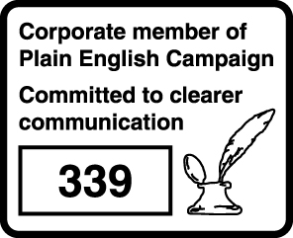

Contents
About Public Health England 2
Introduction 4
Using elements in reports and presentations 4
Feedback 4
Overview of National GP Profiles 5
Quick Guide to Fingertips Features in the National General Practice Profiles 5
Additional information 5
Practice 5
Areas grouped by 6
Benchmark 6
Statistical significance and colour coding 6
Views 7
Spine Chart 8
Bar Chart 9
Trends view 10
Scatter Plot view 10
Definitions 11
Export the data 11
Summary 11

Introduction
The National General Practice Profiles are an interactive web tool (with associated pdf reports) produced by Public Health England Data Science et al.

The tool uses the Fingertips software which was developed by Public Health England to provide easy access to in-depth analysis of a wide range of health related data in thematic profiles.

This user guide focuses on the common features of the Fingertips software and uses examples taken from the National General Practice Profiles. Other profiles developed in the software also share these features. Metadata information on the indicators themselves are available via the ‘Definitions’ section of the profiles.

Using elements in reports and presentations
You are welcome to use elements of Fingertips in your own documents and reports. You may re-use this information (excluding logos) free of charge in any format or medium, under the terms of the Open Government Licence v3.0. To view this licence, visit OGL or email psi@nationalarchives.gsi.gov.uk. Where we have identified any third party copyright information you will need to obtain permission from the copyright holders concerned. Otherwise please acknowledge the source with this statement:
© Crown copyright 2016
Most data used in producing these tools are available as Excel files by clicking the ‘Export data’ button on the tooltab for those who would like to create their own tables or charts.
The population pyramid and the bar charts can be exported as image. The best way to extract other graphics from Fingertips is to use the Snipping Tool (available under Accessories in the Windows Start Menu). If you do not have the Snipping Tool, use the ‘print screen’ button on your keyboard to produce a screen grab which can be pasted into a document and cropped to show the element of interest. Alternatively, the page can be printed from the web.

Feedback
We welcome any comments on the Fingertips tools, in particular, on the usefulness and user friendliness of the tool and on the indicators included. All data in the tools, and the tools themselves, have undergone internal quality assurance. However, we recognise that with the range of data presented in electronic format over the web, errors are possible and request that users alert us to any potential problems if they occur. Please get in touch by clicking ‘Contact Us’ or emailing directly profilefeedback@phe.gov.uk.

Overview of National GP Profiles
These profiles are designed to support GPs, clinical commissioning groups (CCGs) and local authorities to ensure that they are providing and commissioning effective and appropriate healthcare services for their local population.
In addition to viewing individual practice profiles, you can view summary profiles for CCGs. Each practice can be compared with the CCG and England, and also with the practice deprivation decile.
The tool presents a range of practice-level indicators drawn from the latest available data, including:
- Local demography
- Quality and Outcomes Framework domains
- Cancer services
- Child health
- Patient satisfaction
- Antibiotic prescribing

Quick Guide to Fingertips Features in the National General Practice Profiles
Additional information
Links to supporting information such as FAQs are found in the Introduction page of the tool.

Practice
Practices can be selected in two ways, either by navigating via the CCG and then choosing the practice from the drop down:
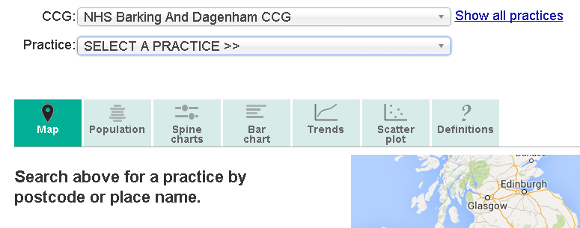
Or by selecting via the map: find a practice by entering a search term or click ‘Show all practices’:
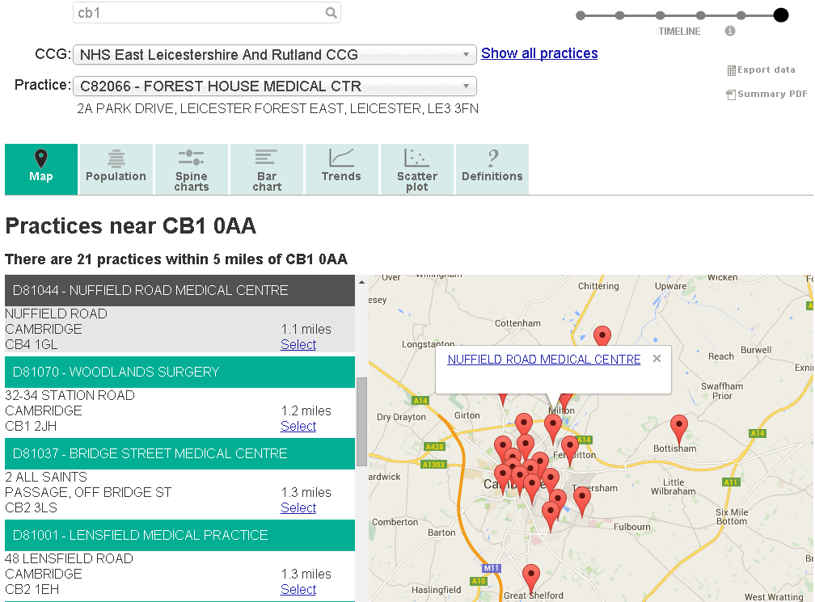

Time line
By default the latest available data point is shown for each indicator. By clicking on a dot further left earlier data points are shown where available for an indicator.
Benchmark
To decide on statistical significance a benchmark needs to be chosen. This is by default England but an additional comparison with more similar areas (deprivation decile or CCG) is also offered in most cases.
Statistical significance and colour coding
A training video on significance is available at https://www.youtube.com/watch?v=zVDcYbf0Y4w

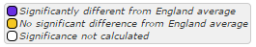

For each indicator, the colour coding shows whether the measure for that area is statistically above or below the comparator (in most cases 99.8% confidence, for details see ‘Definitions’). The benchmark is the national average.
Details of the statistical method used for comparison are available by clicking on the ‘Definitions’ tab. Wherever possible, statistical process control methods have been used for comparison. If the indicator is not coloured it means that no statistical comparison was possible. In most cases this is because the raw data used to calculate the indicator, and which is necessary to undertake statistical comparison, were not available, or the necessary benchmark value could not be obtained.
Within the National GP Profiles indicators have not been assigned a preferred polarity and so appear blue if they are statistically different or yellow if they are similar to the England average.

Views
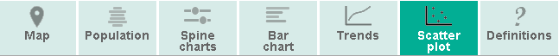
‘Definitions’ provides more details about each indicator, including the data source and rationale. It also gives information on how statistical comparisons are made for each indicator.
‘Bar Chart’ allows the user to view a CCG bar chart for an indicator selected from the drop-down box. Clicking on an indicator within the Spine Chart will also display the Bar Chart.
‘Population’ is the default view. It shows a population pyramid and some summary information about a practice.

‘Scatter Plot’ allows users to select any two indicators and display a scatter plot. The selected practice and CCG practices are highlighted within the plot.
‘Spine Charts’ show the indicators within each of a number of thematic domains.

‘Trends’ allows users to look at data over time, presenting data as a graph and a table. Drop-down boxes allow users to choose the indicator and area of interest and colour-coding indicates whether the values are significantly different from the benchmark.

Population

Population
‘Population’ is the default view once a practice has been selected. On the left of the page there is a population pyramid for the selected practice. This shows the practice in 5 year (quinary) age bands with males to the left and females to the right. The relevant CCG and the England populations are shown as pink and black lines respectively.
To the right of the page there is summary information about the practice. This starts with the practice and CCG registered list size. It is then followed by overall QOF achievement, estimates of male and female life expectancy (where available) and the percentage of patients that would recommend their practice.
The final two boxes on the right of the page show:
- The practice’s deprivation decile using a ‘heat’ scale where more deprived practices will show as red and less deprived practices show as green;
- An estimate of the ethnic mix of the practice population where possible. This is population weighted average derived from the Census 2011.

Spine Chart
A training video on spine charts is available at https://www.youtube.com/watch?v=480Mswgcg8M
This view displays the indicators for the practice. The indicators are grouped by topic and each group can be selected using the drop-down labelled ‘Topic’. Each topic area is displayed as a spine chart.
The indicator data are shown in the form of a spine chart with colour coded points indicating whether the area is significantly different from the England average. Hovering the mouse cursor over elements of the spine chart will give more information about the underlying data.
In the spine chart the red vertical line represents the England benchmark. The light grey bar shows the range between the highest and lowest areas in England with the interquartile range shown in dark grey.
- The interquartile range (dark grey bar) is the difference between the 25th and 75th percentile i.e. if all areas’ values for an indicator are ranked from lowest to highest the 25th percentile is 25% of the way through the ranking and the 75th is 75% of the way through.
- The light grey bar represents the range and skew of the data. If the lowest and highest values are equidistant from the mean the light grey bar will extend evenly across the chart. If the data are skewed towards the lowest values the light grey bar will extend to the left hand side and if the data are skewed towards the highest values the light grey bar will extend to the right hand side.

Colour-coded indicator value
England average
Topic drop-down
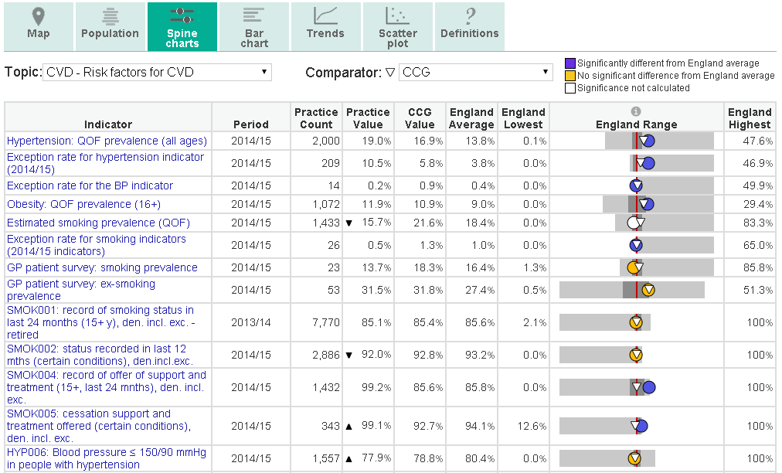
Interquartile range
Range of the data – here, the data is skewed towards the lower values
Each dot represents the area indicator value. Dots to the left of the red line show that the value for this area is lower than the England average, dots to the right of the line show that the value is higher than the England average. The dots are blue if the value is significantly lower or higher and amber if the difference is not significant. Significance is calculated using 3 standard deviation statistical process control.
In addition to the England average users can select an additional benchmark from the drop-down box. This can be either deprivation decile or CCG. The value for the selected comparator is shown on the spine chart by a white inverted triangle (CCG) or a white square (deprivation decile).
Bar Chart
This view can be reached by clicking on the tab labelled ‘Bar Chart’ or by clicking on an indicator from within the spine chart view. The view displays a bar chart for the selected indicator showing all the practices in the selected CCG. If a practice is selected it is identified by a black bar. As with the population pyramid the England value is shown as a black line and the CCG value as a pink line.
England average
CCG average
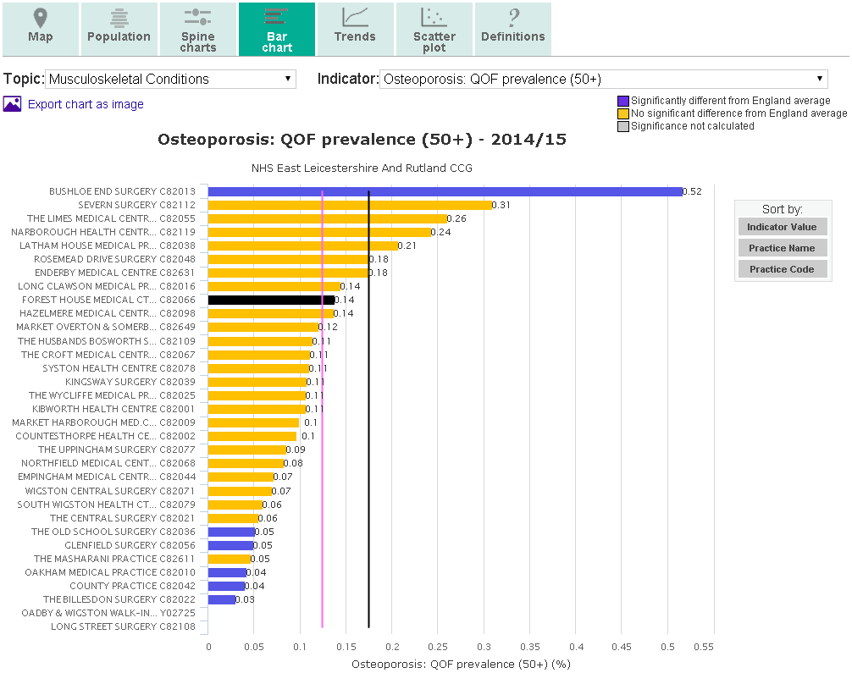
Chart export
The bar chart can be sorted in different ways
Selected practice range

Trends view
This view presents indicator time series data. The drop-down box allows users to select the topic of interest.

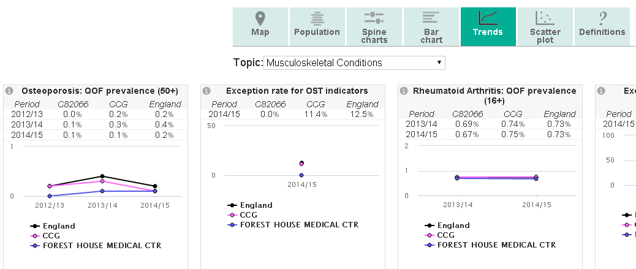
Topic drop-down

For some indicators and for some areas time series data are not available, but for other indicators there is a useful dataset with several time points. A number of QOF indicators have changed their definition over time and so, unless the change is minimal, a time series cannot be shown for these indicators.

Scatter Plot view
This view allows the user to select two indicators and generate a scatter plot. The selected practice is shown as a black cross within the scatter plot and other practices in the CCG are shown as blue dots. All other practices appear as grey dots.
Any indicator within the profiles can be compared against any other indicator. The tool is unable to determine the appropriateness of the chosen comparison and so this judgement must be made by the user.

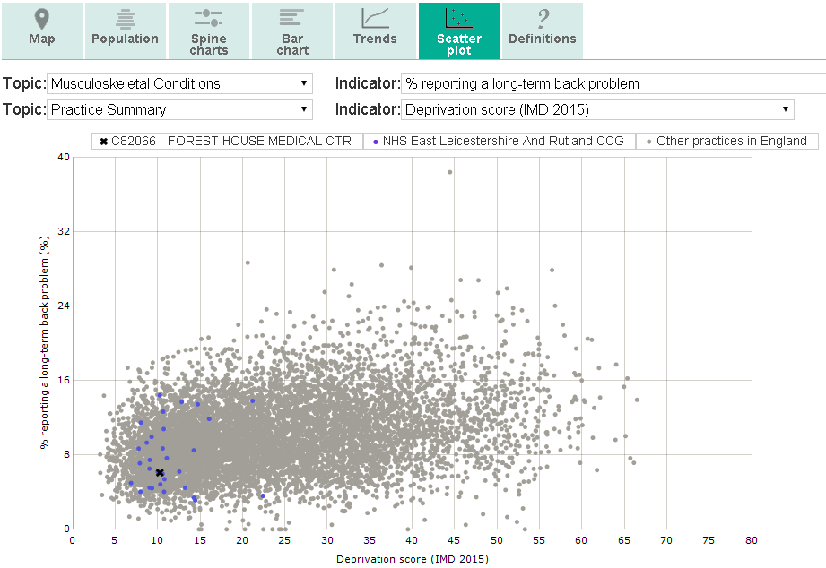
Selected practice

Definitions
For each indicator there is a set of metadata, providing a definition for the indicator, the data source, the methods applied etc. Depending on the purpose, more detailed information might be required than can be provided in the metadata. In this case please see also the FAQs or contact profilefeedback@phe.gov.uk .
Export the data
The underlying data of the spinecharts and the population data can be downloaded into Excel spreadsheets. The data are split into domains and can be downloaded for the selected practice, the CCG or all England.

Summary
A printable version of the practices’ profiles can also be downloaded in PDF format. The PDFs contain the population panel and the spine charts.

